ANALYZING THE GLOBAL IMPACT OF TRUMP’S TARIFFS USING SPATIAL ECONOMETRIC MODELS

A Report Paper

Presented to

Mr. Julito G. Fuerzas

Faculty of the College of Applied Economics

University of Southeastern Philippines

Obrero, Davao City

In Partial Fulfillment

of the Requirements for the Subject

EMETM 7123 SPATIAL ECONOMETRICS

**WILSON JOHN L. DE TOMAS**

May 2025

**Table of Contents**

Rationale 3

Objectives of the Research 3

Theoretical Framework 6

Conceptual Framework 6

Variables 8

Methodology 8

References 12

# R**ational**e

The restraint of imported goods can help in the monopoly of the home market in the importing country, especially when these goods can be produced inside that country. (Smith, 1776). Restraints like high duties on importing agricultural products give an advantage to local producers because the prices they can offer to the consumers will be lower, given that the factors of production of the imported and local agricultural goods are the same. One major form of restraint for goods importation is a tariff. It is a tax imposed on goods by the importing country, and socially, it creates winners and losers. (Parkin, 2012).

This report aims to investigate the key features of the United States’ tariff policies, particularly during the 2017 to 2019 Trump administration. This includes the affected sectors and countries. The report will utilize the Spatial Durbin Model to analyze the impact of the US tariff policy on international trade and highlight significant spatial patterns.

# Objectives of the Research

This report aims to examine the role of tariff rates and gross domestic product in international trade. Specifically:

1. Present an overview of the tariff rates and gross domestic product of US partner countries for the year 2017-2019.
2. Identify the relationship among tariff rate as a factor of gross domestic product and international trade in the US.

# Scope and Delimitations

This report focuses on evaluating the impact of United States tariff policies under the 2017-2019 Trump Administration on international trade. The report covers selected US trading countries and studies the relationship of tariff rates and gross domestic product to international trade during the specified period. Spatial Durbin Model will be employed in the spatial analysis of direct effects and spatial spillover effects of tariffs across neighboring countries. The delimitation are as follows:

* The report is limited to 2017, 2018, and 2019 only.
* It does not account for non-tariff barriers such as quotas, subsidies, and other preferential agreements.
* International trade, as defined in this report, is limited only to the physical movement of goods or a tangible commitment of economic resources.
* Only selected US trading countries with complete and accessible data are included in the analysis.
* Political or diplomatic consequences of tariff policies are not analyzed.
* The Spatial Durbin Model assumes a fixed spatial structure based on country contiguity or GDP-weighted proximity.

# Definition of Terms

For clarity and consistency throughout the report, key terms are defined. The definitions are based on the literature and specific context of this report.

* **Tariff** – a tax imposed by a country on imported goods, intended to make foreign products more expensive and encourage local production. (Parkin, 2012)
* **Applied Harmonized System (AHS) Tariff** – or the Effectively Applied Tariff, lowest applicable tariff rate. (wits.worldbank.org, n.d.)
* **Most-Favored Nation (MFN) Tariffs** – committed tariff rate imposed by the importing country to other members of the WTO. (wits.worldbank.org, n.d.)
* **International Trade** – physical movement of goods or a tangible commitment of economic resources. (Krugman, Obstfeld, & Melitz, 2012)
* **Export** – goods produced in a country but bought by people in other countries. (Mateer, Coppock, & O’Roark, 2016)
* **Import** – goods produced elsewhere but are used domestically within a country. (Mateer, Coppock, & O’Roark, 2016)
* **Net Export** – the difference of exports of goods and services and imports of goods and services. (Parkin, 2012)
* **Spatial Durbin Model (SDM)** – an econometric model that includes the spatial lag of the dependent variable, the explanatory variable vector x, and a spatial lag of the explanatory variable. (LeSage & Pace, 2009)
* **Gross Domestic Product** – the market value of the final goods and services produced within a country in a given time period. (Parkin, 2012)
* **Trade Partner** – a foreign country that engages in the import or export of goods with another nation.
* **Spillover** **Effects** – effects that accrue to countries other than the country itself. (Krugman, Obstfeld, & Melitz, 2012)

# Theoretical Framework

This report is anchored in International Economics, particularly in International Trade Analysis and Gravity Model. International Trade Analysis concentrates primarily on the real transactions with physical movement of goods or a tangible commitment of economic resources in the international economy. (Krugman, Obstfeld, & Melitz, 2012). This report also utilized Spatial Econometrics in drawing connections between geographic and economic interconnections in the international trade dynamics through spatial econometric modelling.

These frameworks assess how the US tariff policies affect the imposed countries but also have spillover effects on neighboring trade partners.

# Conceptual Framework

Figure 1 shows the possible relationship among remittance, bank development and economic growth.

2017-2019 Trump Administration’s Tariff Policies

Changes in Bilateral International Trade

& Tariff Rates

Direct Effects on Targeted Nations

+ Indirect (Spillover) Effects on Neighboring Countries

Spatial Durbin Model

# Related Literature and Studies

In 2016, the world economy's growth was slowing down with a foreseen rise in global debt. This was coupled with the Trade Facilitation Agreement (TFA) of the WTO Agreement in 2014, which was seen to come into motion by 2017 but was having a setback due to the failure of some member states to meet their self-defined negotiating objective of Doha Development Agenda (DDA) in 2001. Compared to other nations, the United States was in a firmer equilibrium due to its favorable policy options during those times. Shatz (2016) defined United States as having less momentum while they are still at a steadier foothold despite having better policy options in 2016.

The major tariff revamps by the Trump Administration were on February, March, and April of 2018. It targeted large residential washing machines, solar panels, steel and aluminum, and the most significant, imports from China. In the paper of Flaaen and Pierce (2019) on the effects of the 2018 tariff, it was noted that there were relative reductions in manufacturing employment and relative increases in producer prices but did not led to increased activity in the U.S. manufacturing sector. Their result suggested that traditional import protection for the promotion of domestic growth is complicated because of globally interconnected supply chains. It also reduces competitiveness due retaliations. (Flaaen & Pierce, 2019)

Globalization helps the US positively but has faced many adverse side-effects on employment and wages. (Petri & Banga, 2020)

Trade Balance could be affected by tariff but not as the main driver since tariff affects how much consumers save or invest locally. According to Altenberg and Merkus (2025), on the correlation of tariff between trade balance in the US, a statistically negative correlation was found for MFN tariff and current account balance. It was further found that OECD countries do not show a significant correlation between tariffs and current account balance. (Altenberg & Merkus, 2025)

# Variables

The dependent variables are the **Net Export** and **Gross Domestic Product**, to assess the effect of the independent variable.

The independent variable is the **US Tariff rate**. Initially, we will use AHS tariff rates since these are the average actual tariff rates applied to the partner country.

# Methodology

This section will be divided into two parts. The first part is the descriptive analysis and trends of net export, GDP, and tariff rates of the US to the rest of the world. The second part is the econometric model that investigates the relationship of tariff rate as a factor of net export and gross domestic product.

1. **Trends of net export, GDP, and tariff rates of the US to the rest of the world**

This study uses graphs and tables to show the trends of net export, GDP, and tariff rates of the US to the rest of the world. Graphs and tables were generated using Microsoft Excel 2019 and RStudio version 4.3.2.

1. **Relationship of tariff rate as a factor of net export and gross domestic product**

Spatial Durbin Model (SDM) was deployed to determine the relationship among the mentioned variables. This model captures both the spatial lag of the dependent variable and spatial lags of explanatory variables.

# Statistical Model

$Y=ρWY+Xβ+WXθ+ε (1)$

Where:

$Y: Vector of net export and GDP$

$W: Spatial weight matrix (geographic/economic proximity)$

$$ρ: Spatial lag coefficient$$

$X: Matrix of explanatory variables (tariffs)$

$θ: Coefficients for spatial lags of X$

# Findings and Conclusions

This section presents the summary and key results derived spatial econometric analysis, including the summary of major conclusions on the impact of US tariff policies to global trade from 2017 to 2021.

1. **Trends of net export, GDP, and tariff rates of the US to the rest of the world**

Table 1 depicts the descriptive summary of the variables of the study. For net export and GDP, we can observe that the spread of the data is very wide for the 195 countries trading with US. This could pose a problem during model creation since AHS values are quite small. Scaling or applying logarithm to net export and GDP will be necessary.

Table 1. Descriptive Statistics of Net Export, GDP, and AHS Tariff

|  |  |  |  |
| --- | --- | --- | --- |
|  | **Net Export** | **GDP** | **Weighted AHS** |
| **Min.** | ($859,467,028,500.00) | $45,276,595.00 | 0.000 |
| **1st Q** | ($954,430,250.00) | $7,662,220,050.00 | 0.050 |
| **Median** | $1,348,780.00 | $37,508,642,165.00 | 0.670 |
| **Mean** | ($12,501,787,762.00) | $1,105,191,410,960.00 | 1.706 |
| **3rd Q** | $152,070,385.00 | $251,104,455,090.00 | 2.020 |
| **Max.** | $32,312,411,520.00 | $81,712,043,350,500.00 | 24.770 |

Table 2 shows the correlation matrix of the three variables. Net Export and GDP have a negative correlation with each other. AHS has a small magnitude of correlation to the other two variables.

Table 2. Correlation Table

|  |  |  |  |
| --- | --- | --- | --- |
|  | **Net Export** | **GDP** | **Weighted AHS** |
| **Net Export** | 1.000 | -0.910 | -0.017 |
| **GDP** | -0.910 | 1.000 | 0.002 |
| **Weighted AHS** | -0.017 | 0.002 | 1.000 |

In Figure 1, we can see the US trade flow segmented per president. It can be observed that US is really a growing major importer of the global market. Steep movement can be observed during the Bush Jr. and Trump administrations.

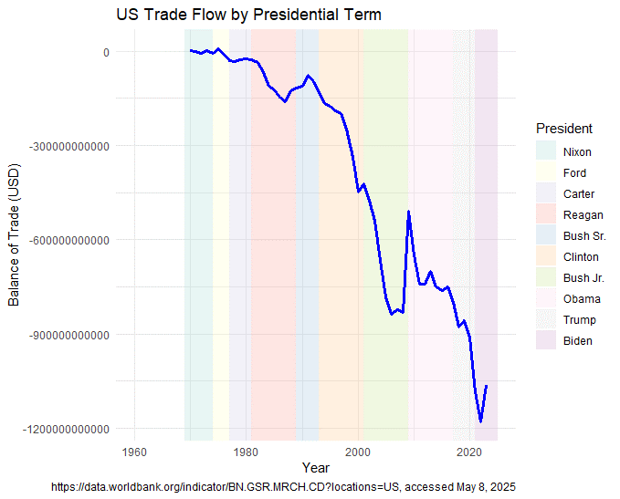Figure 1. US Net Export, per president

Figure 2 illustrates the AHS tariff rate that is segmented with each administration. It can be observed that there is a sudden spike in the AHS tariff rate in 2019. This is due to the effect of the tariff policies implemented in 2018 by the Trump Administration. Particularly in the steel and aluminum, and imports from China.

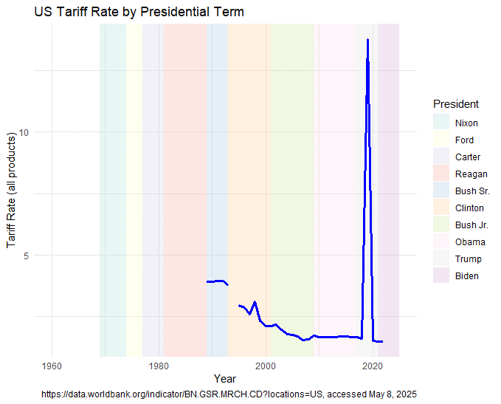Figure 2. AHS Tariff Rate, segmented per president

1. **Relationship of tariff rate as a factor of net export and gross domestic** **product**

The results below are taken from 2017 data. This is prior to the Trump Administration and implementation of the new US tariffs.

Table 3 shows the result of the initial OLS model to get the residuals for the Moran’s I and LM test. The model has an F-statistic = 0.09782 with p-value = 0.7548, indicating that the fit of the model is poor. This is supported by the Multiple R-squared = 0.0005066 and Adjusted R-squared = -0.004672.

|  |  |  |  |  |
| --- | --- | --- | --- | --- |
| **Estimate** | **Std.** | **Error** | **t-value** | **Pr(>|t|)** |
| **(Intercept)** | 0.012 | 0.082 | 0.150 | 0.881 |
| **ahs_weighted** | -0.007 | 0.023 | -0.313 | 0.755 |

Using Contiguity as weights with k-nearest neighbors k = 5, we have the Moran’s I resulting in a significant positive spatial autocorrelation for net export and AHS tariff.

> moran.test(residuals_ols, W_knn)

Moran I test under randomisation

data: residuals_ols

weights: W_knn

Moran I statistic standard deviate = 2.3606, p-value = 0.009123

alternative hypothesis: greater

sample estimates:

Moran I statistic Expectation Variance

0.0450851671 -0.0051546392 0.0004529523

The LM test below shows that no significant spatial autocorrelation in the residuals, which is contrary to the result of the Moran’s I. This discrepancy suggests that the Moran's I test may be picking up weak spatial dependence, but it is not strong enough to affect the OLS model.

> lm.LMtests(ols_model, listw = W_knn, test = "all")

Please update scripts to use lm.RStests in place of lm.LMtests

model: lm(formula = trade_bal ~ ahs_weighted, data = data_2017)

test weights: listw

RSerr = 1.1387, df = 1, p-value = 0.2859

model: lm(formula = trade_bal ~ ahs_weighted, data = data_2017)

test weights: listw

RSlag = 1.1733, df = 1, p-value = 0.2787

model: lm(formula = trade_bal ~ ahs_weighted, data = data_2017)

test weights: listw

adjRSerr = 0.54433, df = 1, p-value = 0.4606

model: lm(formula = trade_bal ~ ahs_weighted, data = data_2017)

test weights: listw

adjRSlag = 0.57893, df = 1, p-value = 0.4467

model: lm(formula = trade_bal ~ ahs_weighted, data = data_2017)

test weights: listw

SARMA = 1.7176, df = 2, p-value = 0.4237

Proceeding with SDM to check the validity of LM test, we have the results below. Note that net export had to be scaled using z-scores to proceed with the SDM in R due to numerical stability of the model when running in R. The SDM resulted with no significant estimates. The AIC (560.32) is very close to the AIC of the OLS model (559.7), suggesting that the Spatial Durbin Model (SDM) doesn't significantly improve the model fit compared to OLS for this dataset.

> summary(sdm_knn)

Call:lagsarlm(formula = form, data = data_2017, listw = W_knn, type = "mixed")

Residuals:

Min 1Q Median 3Q Max

-12.834581 0.073442 0.102499 0.165891 1.333846

Type: mixed

Coefficients: (asymptotic standard errors)

Estimate Std. Error z value Pr(>|z|)

(Intercept) 0.0501800 0.1047391 0.4791 0.6319

ahs_weighted -0.0030022 0.0232217 -0.1293 0.8971

lag.ahs_weighted -0.0282627 0.0403142 -0.7011 0.4833

Rho: 0.15645, LR test value: 1.3831, p-value: 0.23957

Asymptotic standard error: 0.10992

z-value: 1.4233, p-value: 0.15465

Wald statistic: 2.0258, p-value: 0.15465

Log likelihood: -275.1609 for mixed model

ML residual variance (sigma squared): 0.9806, (sigma: 0.99025)

Number of observations: 195

Number of parameters estimated: 5

AIC: 560.32, (AIC for lm: 559.7)

LM test for residual autocorrelation

test value: 9.2962, p-value: 0.0022963

The Spatial Durbin Model doesn't show significant improvements over the OLS model in terms of coefficients and fit. While the model detects some spatial autocorrelation in the residuals, the spatial effects in the model itself are not significant.

GDP and AHS tariff was also modeled with each other to see the effect of tariff rates on GDP of US trade partners. The result below indicates the OLS model get the residuals. The GDP variable had also been scaled to avoid numerical stability of the model when running SDM in R. It also yielded the same conclusion as with net export and AHS tariff when proceeding to SDM in R.

> summary(gdp_ols_model)

Call:

lm(formula = gdp_2017_z ~ ahs_weighted, data = data_2017)

Residuals:

Min 1Q Median 3Q Max

-0.5432 -0.2714 -0.2576 -0.1263 11.2365

Coefficients:

Estimate Std. Error t value Pr(>|t|)

(Intercept) -0.02133 0.08179 -0.261 0.795

ahs_weighted 0.01244 0.02291 0.543 0.588

Residual standard error: 1.002 on 193 degrees of freedom

Multiple R-squared: 0.001525, Adjusted R-squared: -0.003648

F-statistic: 0.2948 on 1 and 193 DF, p-value: 0.5878

> moran.test(gdp_residuals_ols, W_knn)

Moran I test under randomisation

data: gdp_residuals_ols

weights: W_knn

Moran I statistic standard deviate = 3.7066, p-value = 0.000105

alternative hypothesis: greater

sample estimates:

Moran I statistic Expectation Variance

0.1107269873 -0.0051546392 0.0009773956

> lm.LMtests(gdp_ols_model, listw = W_knn, test = "all")

Please update scripts to use lm.RStests in place of lm.LMtests

model: lm(formula = gdp_2017_z ~ ahs_weighted, data = data_2017)

test weights: listw

RSerr = 6.8681, df = 1, p-value = 0.008775

data:

model: lm(formula = gdp_2017_z ~ ahs_weighted, data = data_2017)

test weights: listw

RSlag = 7.0926, df = 1, p-value = 0.00774

data:

model: lm(formula = gdp_2017_z ~ ahs_weighted, data = data_2017)

test weights: listw

adjRSerr = 1.1905, df = 1, p-value = 0.2752

data:

model: lm(formula = gdp_2017_z ~ ahs_weighted, data = data_2017)

test weights: listw

adjRSlag = 1.4151, df = 1, p-value = 0.2342

data:

model: lm(formula = gdp_2017_z ~ ahs_weighted, data = data_2017)

test weights: listw

SARMA = 8.2831, df = 2, p-value = 0.0159

> summary(sdm_knn)

Call:lagsarlm(formula = form_gdp, data = data_2017, listw = W_knn, type = "mixed")

Residuals:

Min 1Q Median 3Q Max

-1.03791 -0.24889 -0.16377 -0.11578 11.12486

Type: mixed

Coefficients: (asymptotic standard errors)

Estimate Std. Error z value Pr(>|z|)

(Intercept) -0.0671017 0.1025203 -0.6545 0.5128

ahs_weighted 0.0043049 0.0227193 0.1895 0.8497

lag.ahs_weighted 0.0415448 0.0395514 1.0504 0.2935

Rho: 0.30248, LR test value: 6.8371, p-value: 0.0089285

Asymptotic standard error: 0.09712

z-value: 3.1144, p-value: 0.0018429

Wald statistic: 9.6998, p-value: 0.0018429

Log likelihood: -271.9142 for mixed model

ML residual variance (sigma squared): 0.93743, (sigma: 0.96821)

Number of observations: 195

Number of parameters estimated: 5

AIC: 553.83, (AIC for lm: 558.67)

LM test for residual autocorrelation

test value: 8.7981, p-value: 0.0030155

In conclusion for the year 2017, the report coincides with the findings of Flaaen & Pierce (2019) where tariff has little to no effect on the economic growth of US.

For the year 2018 and 2019, it also yielded the same results and therefore conclude that there are other factors that might play a significant role in the US Global Trade instead of tariff rates.

# References

Altenberg, P., & Merkus, E. (2025). Tariffs do not Improve the Trade Balance. *The National Board of Trade Sweden*. Retrieved from https://www.kommerskollegium.se/globalassets/publikationer/rapporter/2025/tariffs-do-not-improve-the-trade-balance.pdf

Flaaen, A., & Pierce, J. (2019). Disentangling the Effects of the 2018-2019 Tariffs on a Globally Connected U.S. Manufacturing Sector. *Finance and Economics Discussion Series 2019-086*. Retrieved from https://www.federalreserve.gov/econres/feds/disentangling-the-effects-of-the-2018-2019-tariffs-on-a-globally-connected-us-manufacturing-sector.htm

Krugman, P. R., Obstfeld, M., & Melitz, M. J. (2012). nternational economics: Theory and policy (9th ed.). Pearson Education.

LeSage, J., & Pace, R. (2009). *Introduction to spatial econometrics. Chapman & Hall/CRC.* Retrieved from https://g-city.sass.org.cn/_upload/article/files/03/15/9d94a3194345bc4f0b8c8c9aed32/9bccc017-0b30-4b35-83eb-26052e2a48b7.pdf

Mateer, D., Coppock, L., & O’Roark, B. (2016). *Essentials of economics (1st ed.).* W. W. Norton & Company.

Parkin, M. (2012). Macroeconomics (10th ed.). Pearson Education.

Petri, P. A., & Banga, M. (2020). The Economic Consequences of Globalisation in the United States. *ERIA Discussion Paper Series*, 21. Retrieved from https://www.eria.org/uploads/media/discussion-papers/The-Economic-Consequences-of-Globalisation-in-the-United-States.pdf

Shatz, H. J. (2016, June 21). *Charting the U.S. role in the world economy (RAND Research Brief RB-9918-RC).* Retrieved from https://www.rand.org/content/dam/rand/pubs/research_briefs/RB9900/RB9918/RAND_RB9918.pdf

Smith, A. (1776). *An Inquiry into the Nature and Causes of the Wealth of Nations.* Retrieved from http://gesd.free.fr/smith76bis.pdf

wits.worldbank.org. (n.d.). *Types of Tariff*. Retrieved from https://wits.worldbank.org/wits/wits/witshelp/content/data_retrieval/p/intro/c2.types_of_tariffs.htm